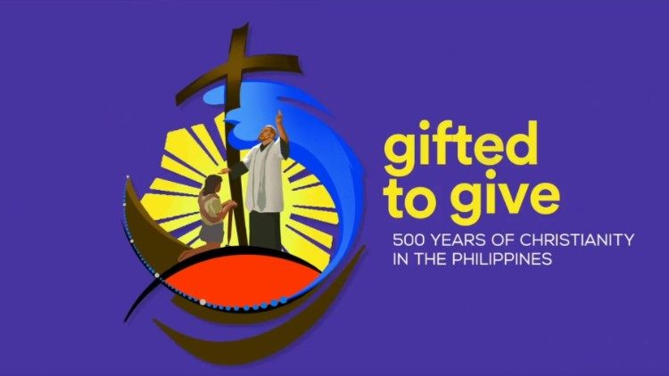
JOIN THE CELEBRATION OF THE
500th YEAR OF THE GIFT OF THE CATHOLIC FAITH TO THE FILIPINO PEOPLE
1521-2021

Hosted by: Holy Family Church - Artesia, CA
in partnership with 30 parish-based Filipino Ministries in the San Pedro Pastoral Region of the Archdiocese of Los Angeles, in collaboration with the Catholic Bishops Conference of the Philippines, the Archdiocese of Manila and the United States Conference of Catholic Bishops – Asian and Pacific Affairs

Organized by: The Filipino-American Catholic Community (FILAMCC) of Holy Family

MABUHAY, LONG LIVE THE FILIPINO CATHOLIC FAITH!
Saturday, September 25, 2021

2:00-6:00 PM - Exhibits on history, Filipino Saints , Filipino American Gifts to the Catholic Church
-Entertainment and Food Trucks
3:00-4:30 PM - Seminar: “A Treasured Presence: Filipino American Catholics” by Fr. Ricky Manalo, CSP
5:00-5:45 PM - Procession – Carozas with Sto. Nino and Filipino Saints, photos of Blesseds and Venerables, sinulog and ati-atihan dancers, Knights of Columbus marshalls
6:00-6:30 PM - Rosary
6:30-7:30 PM - Multicultural Holy Mass with Bishop Marc Trudeau, Presider, concelebrated with Filipino Priests in the San Pedro Region

For more information contact:
Lucille Parisho (562) 331-4012Or email: Luci.Parisho@gmail.com
Or Joe Vicente HFUltreya@holyfamilyartesia.org

For souvenir T-shirts, tote bags, book – A Treasured Presence contact: Noel Motus: 562 282 3071 or noelmotus7@gmail.com

